EXP NO 4
TRAIN RESERVATION SYSTEM

Aim
To develop a Train Reservation webpage that allows users to enter passenger details, select source, destination, journey date, and coach class, and generate a ticket confirmation with a PNR number.
Procedure
- Create the webpage using HTML and CSS.
- Design separate sections for travel information and ticket booking.
- Add input fields for passenger name and journey date.
- Provide dropdown menus for source, destination, and coach class.
- Use JavaScript to validate the details and generate ticket confirmation.
- Display passenger details, journey information, coach class, and PNR number.
- Run the webpage in a browser and verify the output.
Code
<!DOCTYPE html>
<html>
<head>
<title>Train Reservation</title>
<style>
body{margin:0;font-family:Arial;background:#eaf4ff;}
header{background:#003366;color:#fff;padding:15px;text-align:center;}
.main{display:flex;justify-content:center;gap:30px;padding:30px;}
.left{width:35%;background:#003366;color:#fff;padding:20px;border-radius:10px;}
.right{width:35%;background:#fff;padding:20px;border-radius:10px;box-shadow:0 0 8px gray;}
input,select,button{width:100%;padding:8px;margin:8px 0;}
button{background:#003366;color:#fff;border:none;cursor:pointer;}
button:hover{background:#0055aa;}
#ticket{margin-top:15px;background:#dff0d8;padding:10px;border-radius:5px;display:none;}
</style>
</head>
<body>

<header><h1>🚆 Express Train Reservation</h1></header>

<div class="main">

<div class="left">
<h2>Travel With Us</h2>
<p>✔ Fast Booking</p>
<p>✔ Secure Reservation</p>
<p>✔ Instant Confirmation</p>
<p>✔ Multiple Classes</p>
<p><b>Book your train tickets in minutes!</b></p>
</div>

<div class="right">
<h2>Book Ticket</h2>

<input id="name" placeholder="Passenger Name">

<select id="from">
<option>From</option>
<option>Chennai</option>
<option>Bangalore</option>
<option>Madurai</option>
</select>

<select id="to">
<option>To</option>
<option>Delhi</option>
<option>Mumbai</option>
<option>Hyderabad</option>
</select>

<input type="date" id="date">

<select id="coach">
<option>Sleeper</option>
<option>AC 3 Tier</option>
<option>AC 2 Tier</option>
</select>

<button onclick="book()">Book Now</button>

<div id="ticket"></div>

</div>

</div>

<script>
function book(){
let n=name.value,f=from.value,t=to.value,d=date.value,c=coach.value;
if(n==""||f=="From"||t=="To"||d==""){
alert("Enter all details");
}
else{
ticket.style.display="block";
ticket.innerHTML="<h3>🎫 Ticket Confirmed</h3>"
+"Passenger: "+n+"<br>"
+"Route: "+f+" ➜ "+t+"<br>"
+"Date: "+d+"<br>"
+"Class: "+c+"<br>"
+"PNR: "+Math.floor(Math.random()*900000);
}
}
</script>

</body>
</html>

Output

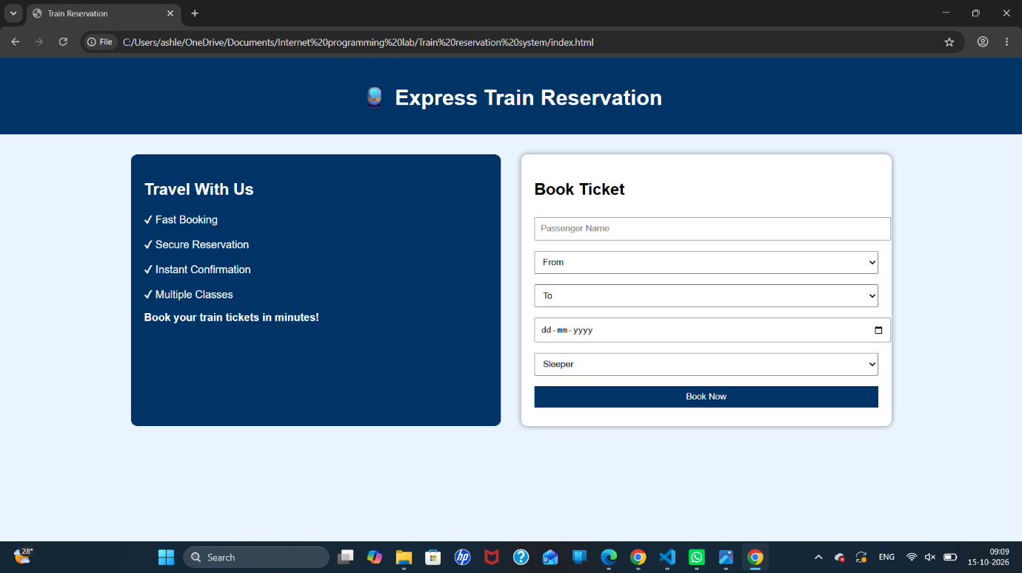

Result
Thus, the Train Reservation webpage was created successfully with passenger details, journey selection, coach selection, ticket confirmation, and PNR number generation.

